Statistical and Probability Analysis of Balaji Fast Food Sales Data Using R
Student Name: Nikita Mishra
Section:18 ALY6010 Probability Theory and Introductory Statistics
Module 1 – R Practice Assignment
Instructor: Shahram Sattar
NUID: 003181521
Date: 24/02/2026

Dataset Information and Introduction
The dataset selected for this assignment is “Balaji Fast Food Sales.” After importing the dataset into R Studio and applying the str(), summary(), and head() functions, an initial overview of the dataset was obtained. The dataset contains transactional sales records, including invoice ID, sales date, item description, product category, price per unit, units sold, total sales value, payment type, and time of sale. These variables provide detailed insights into customer purchasing behaviour and revenue generation patterns.
This report presents a statistical analysis of the Balaji sales dataset, with particular focus on examining whether the transaction amounts (sales value) follow a normal distribution. Understanding the distribution pattern of sales values is essential in business analytics because it helps identify the central tendency (mean), variability (standard deviation), and overall spread of the data. If the sales data approximately follows a normal distribution, it suggests a symmetric, bell-shaped pattern where most transactions cluster around the average value, with relatively fewer extremely high or low transactions.
Establishing the distribution pattern enables the application of probability-based methods for interpretation and decision-making. In this analysis, a specific sales value of 500 is highlighted to determine its relative position within the dataset. By comparing this value to the dataset’s mean and standard deviation, a standardized score (z-score) can be calculated to evaluate whether it represents an average transaction or a significantly high or low sale. This approach demonstrates how concepts of normal distribution and probability can be practically applied in real-world sales analysis to support data-driven insights and business evaluation.

Initial Setup
The workspace was cleared using rm(list = ls()) and cat('\014') to ensure no previous objects interfered with the analysis. Required libraries such as dplyr, tidyverse, ggplot2, lubridate, and gmodels were loaded for data manipulation, visualization, and cross-tabulation.
Dataset Import  The dataset was imported using read.csv() and stored in an object named 'Balaji' for further processing. | 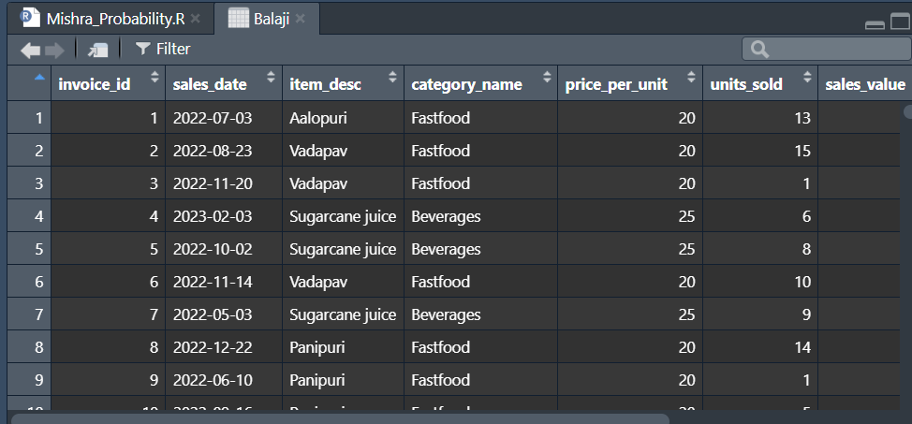

PART 1 – Data Cleaning and Preparation
A. Dataset Review and Initial Exploration
The functions str(), summary(), and head() were used to examine the structure, summary statistics, and preview the dataset. This helped identify variable types, missing values, and overall data layout.
Screenshot: str() and summary() Output
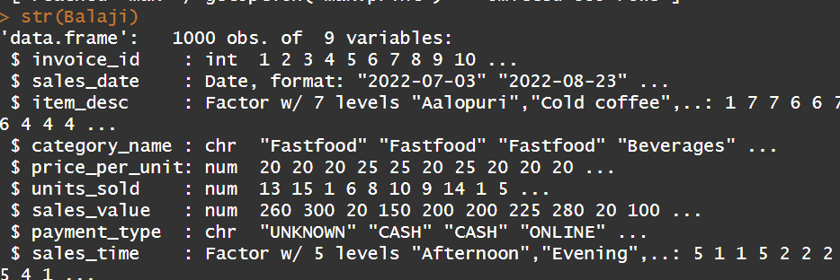 | 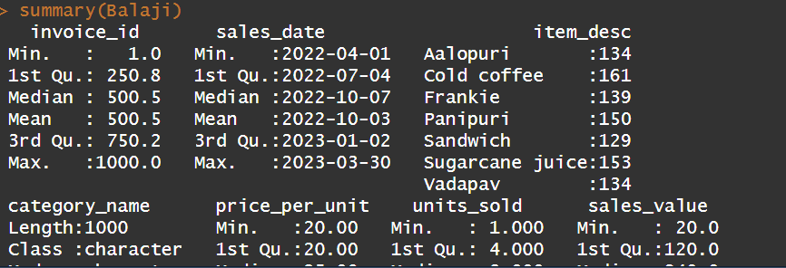

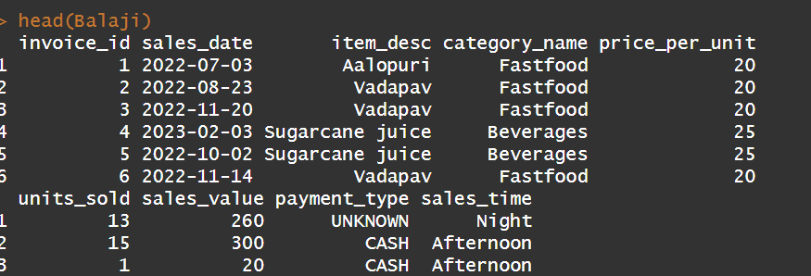
Explanation The str() function shows the structure and data types of each variable, while summary() provides descriptive statistics including minimum, maximum, mean, and quartiles. This step ensures understanding of data composition and helps detect anomalies or inconsistencies.

B. Renaming Variables  Columns were renamed using the rename() function to make them more meaningful and analysis-friendly. This improves readability and ensures clarity during interpretation. | 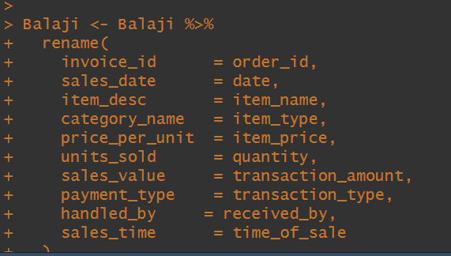
Explanation: The str() function shows the structure and data types of each variable, while summary() provides descriptive statistics including minimum, maximum, mean, and quartiles. This step ensures understanding of data composition and helps detect anomalies or inconsistencies.

C. Handling Missing / Blank Values  Blank values in the payment_type column were replaced with 'Unknown' to maintain consistency and prevent analytical errors. | 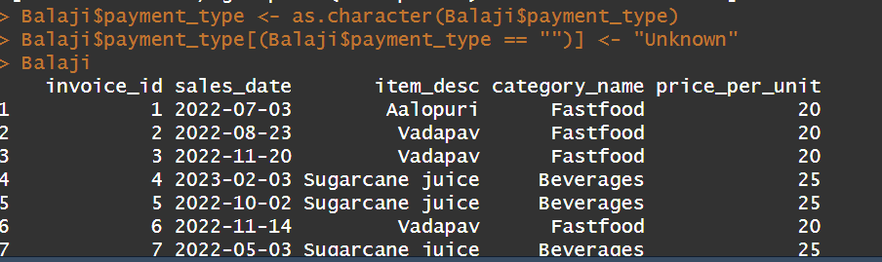
Explanation: Blank entries in payment_type were replaced with 'Unknown'. This prevents exclusion of transactions and ensures accurate categorical analysis.

D. Handling Invalid Values  Negative values in units_sold were replaced with 0 using ifelse(). This ensures logical correctness since quantity cannot be negative. | 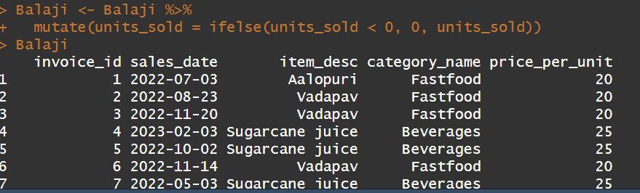

Explanation: Negative units_sold values were replaced with 0 to maintain logical validity. Sales quantities cannot be negative; correcting them ensures accurate statistical computation.
E. Applying Appropriate Data Types  Variables were converted into appropriate data types (Date, factor, numeric) using mutate(). Correct data types are essential for accurate statistical computation and visualization. | 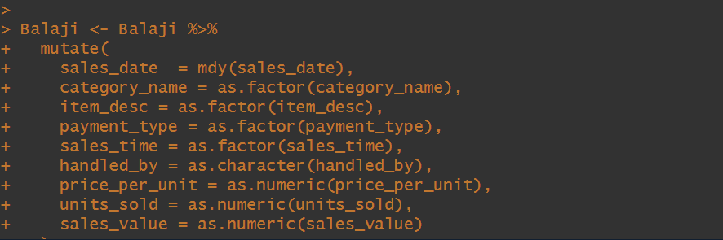

Explanation: Variables were converted to appropriate types (Date, factor, numeric). Correct formatting is essential for grouping, visualization, and probability modeling.

F. Removing Unnecessary Column  The 'handled_by' column was removed because it was not required for statistical analysis. | 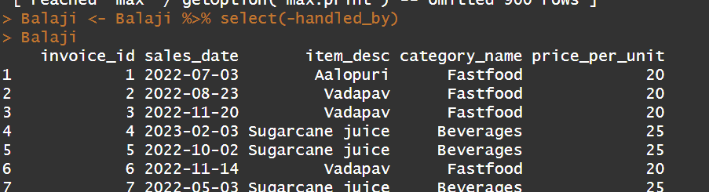
Explanation: The 'handled_by' column was removed as it was not required for statistical analysis, simplifying the dataset and focusing only on relevant variables.

G. String Cleaning  String manipulation functions were used to trim extra spaces and standardize text formatting to avoid duplication errors. | 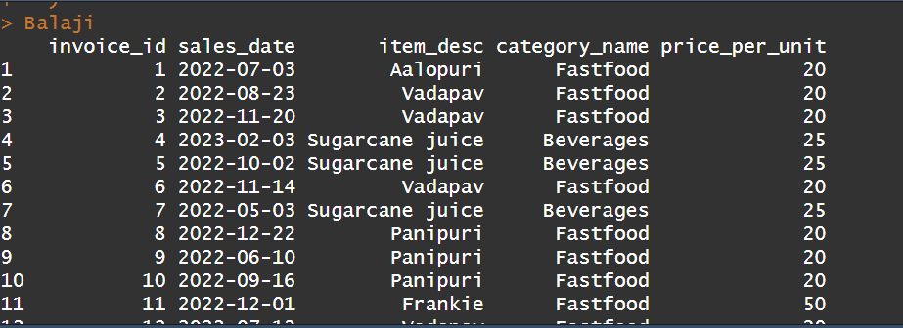
Explanation: It Cleans strings values.

H. Removing Duplicate Records  Duplicate transactions were removed using distinct() to ensure each transaction is counted only once. | 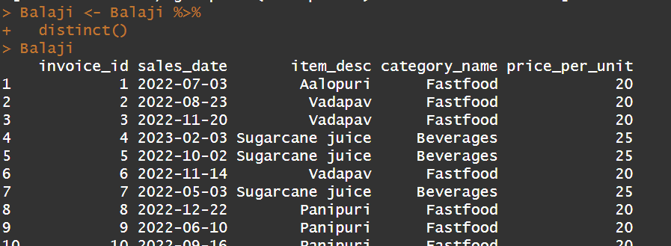
Explanation: Duplicate rows were removed to ensure each transaction is counted only once. This prevents distortion in frequency counts and summary statistics.
PART 2 – Descriptive Statistics and Visualization
A. Frequency Tables
Frequency tables were created using table() to analyze the distribution of categories, payment types, and sales time. This helps identify popular products and customer payment preferences.
Screenshot: Frequency Table Output
- Sales time table with Category name.  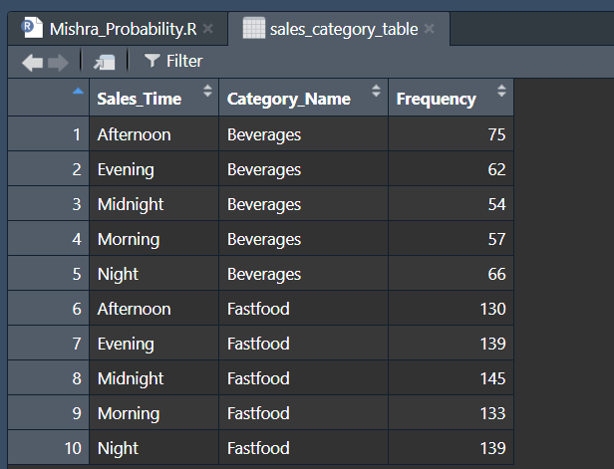 | - Sales time table with Frequency.  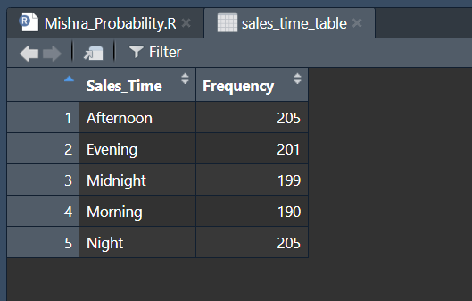
- Payment table with type  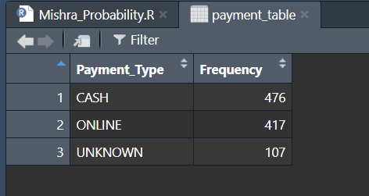 | - Category table with Payment time  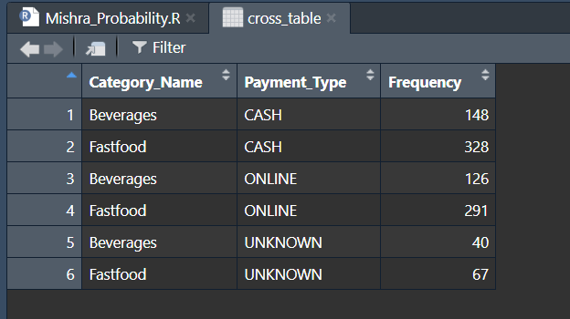

Explanation: The dataset consists of 1,000 total transactions. Among them, Fastfood accounts for 686 transactions (68.6%), while Beverages account for 314 transactions (31.4%). This indicates that Fastfood contributes to more than two-thirds of total sales activity.
In terms of payment type, Cash transactions account for 476 (47.6%), Online transactions for 417 (41.7%), and Unknown transactions for 107 (10.7%). This shows that while Cash remains slightly dominant, digital payments represent a significant portion of total sales.
Sales are relatively evenly distributed across time periods, with Afternoon and Night each accounting for 205 transactions (20.5%), followed closely by Evening (20.1%), Midnight (19.9%), and Morning (19.0%). This suggests consistent customer activity throughout the day.
B. Cross Tabulation
Cross-tabulation was performed using table(), ftable(), and CrossTable() to examine relationships between product categories and payment types. Row and column percentages were analyzed to understand purchasing patterns.

1. Relationship between product category and mode of payment
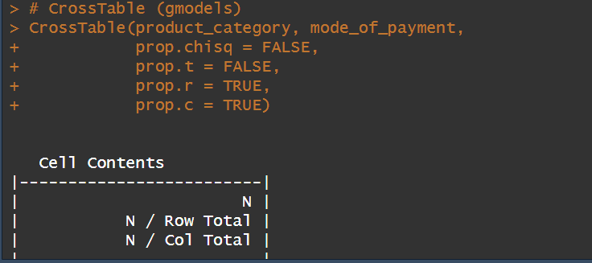 | 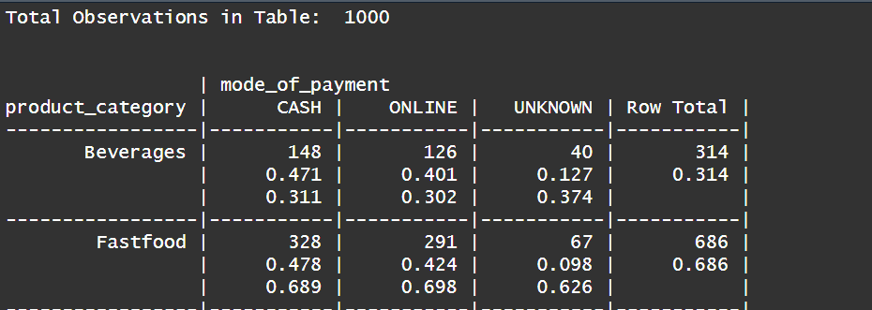

2. joint frequency distribution between product category and mode of payment
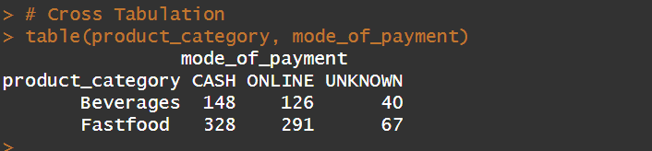 | 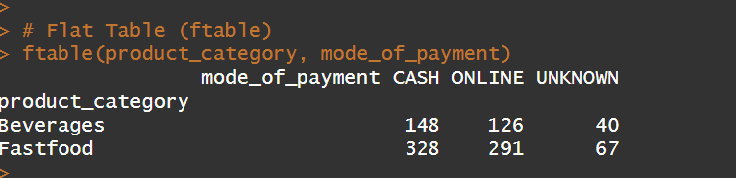
Explanation: The cross-tabulation shows that for Beverages, 148 transactions (47.1%) were paid by Cash, 126 (40.1%) Online, and 40 (12.7%) Unknown, while for Fastfood, 328 transactions (47.8%) were Cash, 291 (42.4%) Online, and 67 (9.8%) Unknown, indicating similar payment patterns with Cash slightly higher than Online in both categories.
C. Histograms
Histograms were created for units_sold, price_per_unit, and sales_value to understand distribution shape, spread, skewness, and presence of outliers.
Screenshot 5: Histogram Outputs
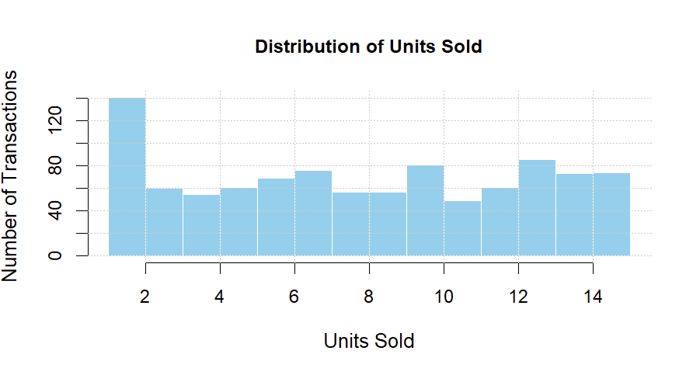 | 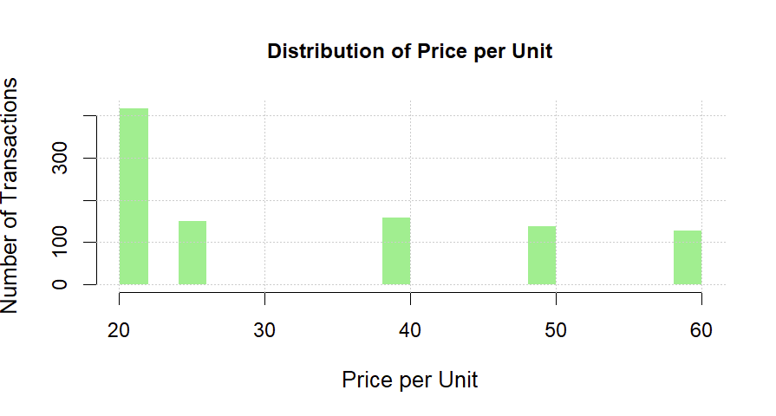
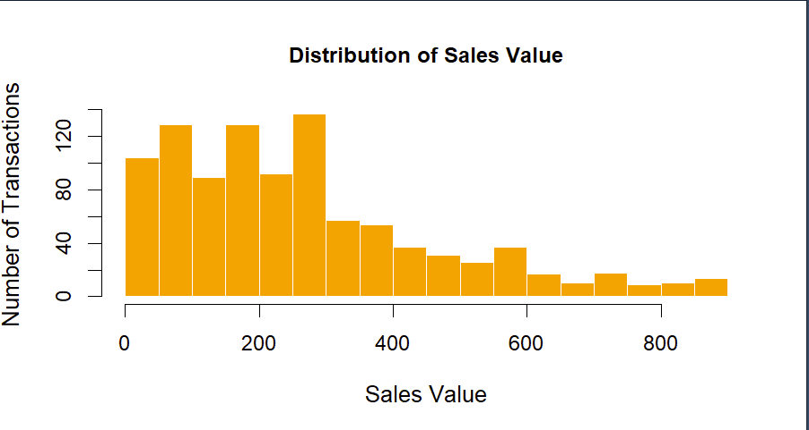
Explanation: Histograms display the distribution shape, spread, and skewness of numerical variables. The sales_value histogram is crucial for evaluating approximate normality before probability modeling.
PART 3 – Comparative and Relationship Analysis
A. Boxplot Comparison and Bar Chart
Mean sales values were calculated using aggregate (). A boxplot was created to compare sales value across categories. This helps analyze median differences, variability, and outliers.

Screenshot: Boxplot Output
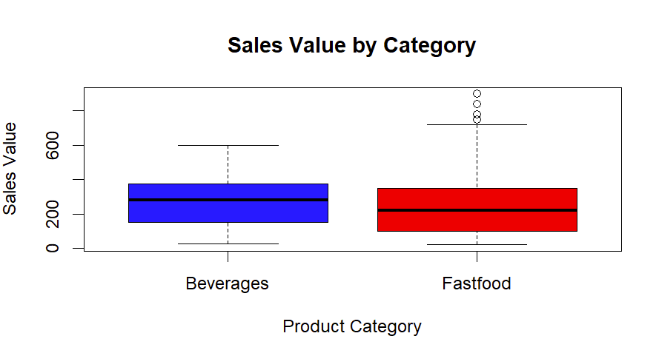
Screenshot: Bar Chart
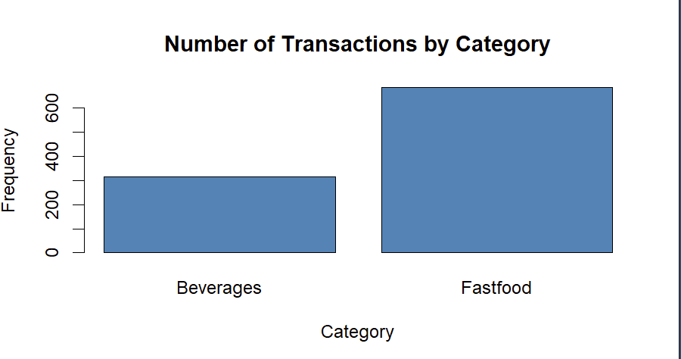
Explanation:
Bar Chart:
Fastfood has about 700 transactions (≈70%), while Beverages has about 300 transactions (≈30%), showing Fastfood dominates in volume.
Boxplot:
The mean sales values are nearly identical — Beverages: 275.13 and Fastfood: 275.28 (difference = 0.15), indicating similar revenue per transaction despite the difference in transaction count.
B. Scatter Plot and Correlation Analysis
Scatter plots were created to examine relationships between units_sold and sales_value, and between price_per_unit and sales_value. Regression lines were added, and correlation coefficients were calculated to measure strength of relationships.
Screenshot: Scatter Plot Outputs
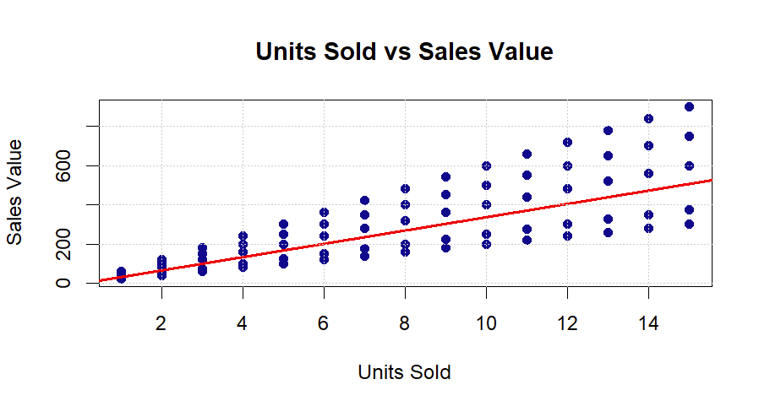 | 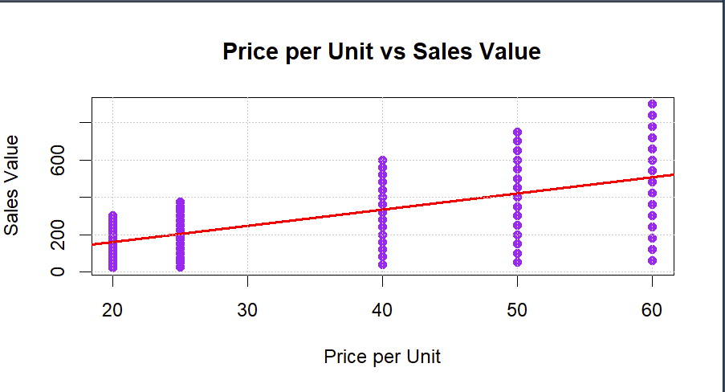
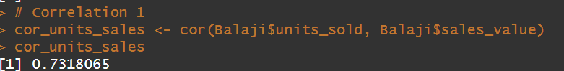 | 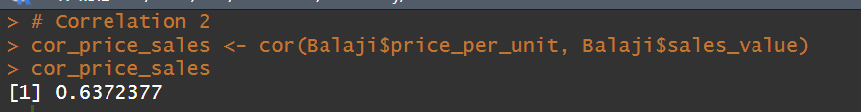
Explanation: The correlation between units sold and sales value (r = 0.7318) shows a strong positive relationship, while the correlation between price per unit and sales value (r = 0.6372) indicates a moderate positive relationship; since 0.7318 > 0.6372, quantity has a stronger impact on revenue, with a difference of 0.0946, confirming that increasing sales volume contributes more to revenue growth than price changes.
C – Probability Analysis
Normal Distribution Modeling
Mean and standard deviation of sales_value were calculated. Sales value was assumed to follow a Normal distribution for probability estimation.
Screenshot-Mean and Standard Deviation Output
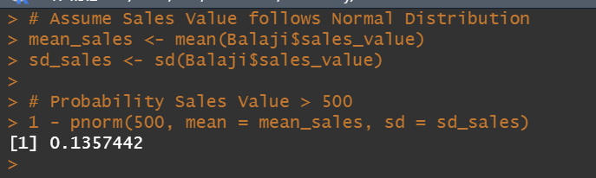
Probability Calculations:
Using pnorm(), probabilities were calculated for sales_value greater than 500 and between 200 and 600. These probabilities estimate likelihood of high-value and moderate-value transactions.
Screenshot: Probability Output
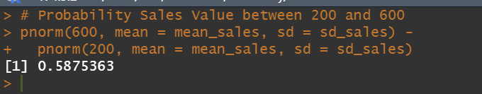
Explanation: The mean sales value is 275.20, and the probability that sales exceed 500 is 0.1357 (13.57%), indicating that high-value transactions are relatively uncommon. The probability that sales fall between 200 and 600 is 0.5875 (58.75%), showing that most transactions occur within the moderate range; since 500 is well above the mean, it represents a higher-than-average but not extremely rare transaction.

D. Probability Visualization  A Normal distribution curve was plotted using dnorm(), and a vertical reference line was added to highlight a probability threshold. | 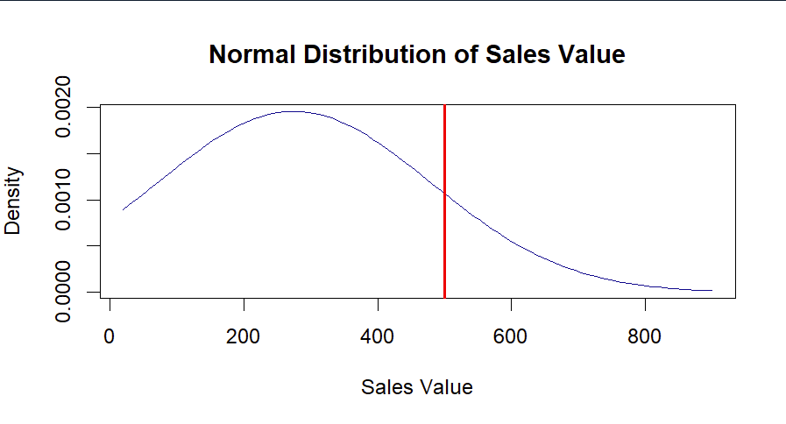
Explanation: The Normal distribution curve visually represents probability density. The vertical threshold line highlights the position of 500 relative to the mean.
CONCLUSION
The statistical analysis of the Balaji Fast Food Sales dataset provides meaningful insights into transaction behavior and revenue patterns. The results show that Fastfood contributes 68.6% of total transactions, while Beverages account for 31.4%, indicating a higher customer demand for Fastfood items. However, despite this difference in transaction volume, the average sales value per transaction is nearly identical between the two categories (275.28 vs 275.13), suggesting consistent pricing and purchasing behaviour across product types. The correlation analysis further reveals that revenue is more strongly influenced by sales volume (r = 0.7318) than by price variation (r = 0.6372), confirming that increasing quantity sold has a greater impact on total revenue than minor pricing adjustments. This finding highlights the importance of sales volume strategies, such as promotions or bundle offers, in driving business growth.
The probability analysis extends the study by modelling sales value using a normal distribution. With a mean sales value of approximately 275.20, only 13.57% of transactions exceed 500, while 58.75% fall within the moderate range of 200–600. This indicates that most transactions cluster around the average, with fewer extreme high-value sales. By integrating descriptive statistics, visualization techniques, correlation analysis, and probability modelling, this study demonstrates how statistical tools can support revenue forecasting and data-driven decision-making. Overall, the analysis provides a comprehensive understanding of sales performance, identifies key revenue drivers, and illustrates the practical application of probability theory in business analytics.
References
1. Kaggle. Balaji Fast Food Sales Dataset. Retrieved February 24, 2026, from:
https://www.kaggle.com/datasets/rajatsurana979/fast-food-sales-report
2. “Descriptive Statistics in R.” Quick-R. Retrieved February 24, 2026, from: https://www.statmethods.net/stats/descriptives.html
3. “CrossTable Function.” gmodels R Documentation. Retrieved February 24, 2026, from: https://cran.r-project.org/package=gmodels
4. “Normal Distribution in R (dnorm, pnorm, qnorm, rnorm).” R Documentation. Retrieved February 24, 2026, from: https://stat.ethz.ch/R-manual/
5. “Scatterplots in R.” Quick-R. Retrieved February 24, 2026, from: https://www.statmethods.net/graphs/scatterplot.html

